**PHP - AJAX Project**

RAVI PUNAR (1MY19MCA13)

SUBHADIP MAHAPATRA (1MY19MCA21)



1. This is the Homepage of the Project.

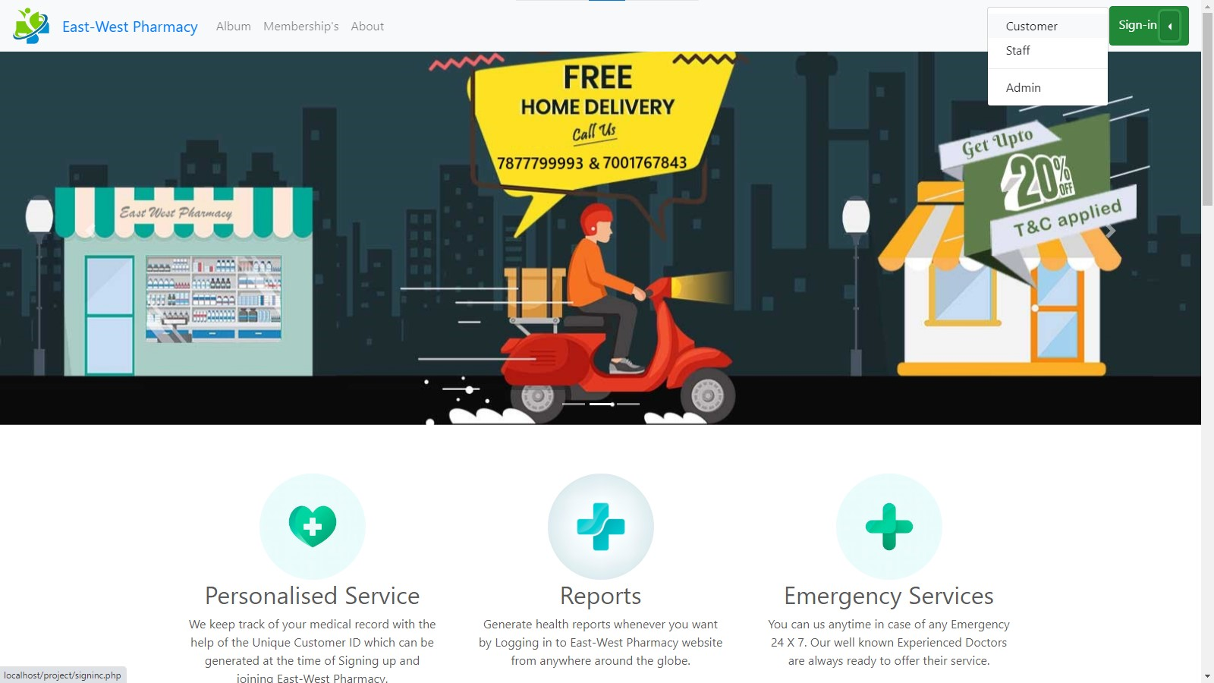

1. Sign in Button shows the different types of users to signin.here we click on the Customer which will redirect to customer signin page.

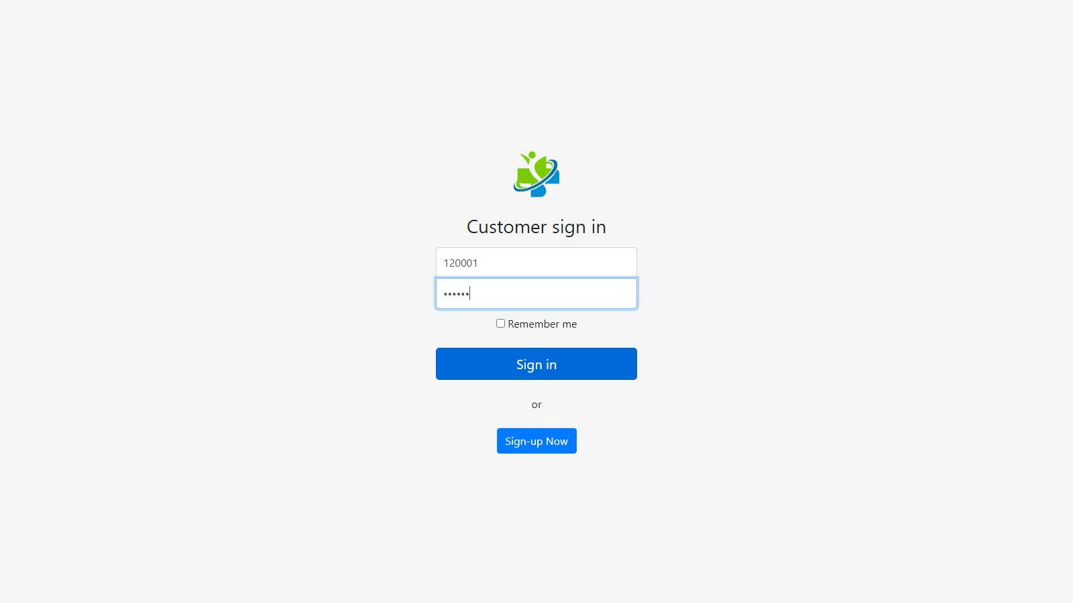

1. Enter customer signin and password generated at the time of Sign-up. Customer ID is automatically generated which helps to navigate as per the type of different requirements of user.When clicked sign-in it will redirect us to Customer Dashboard.

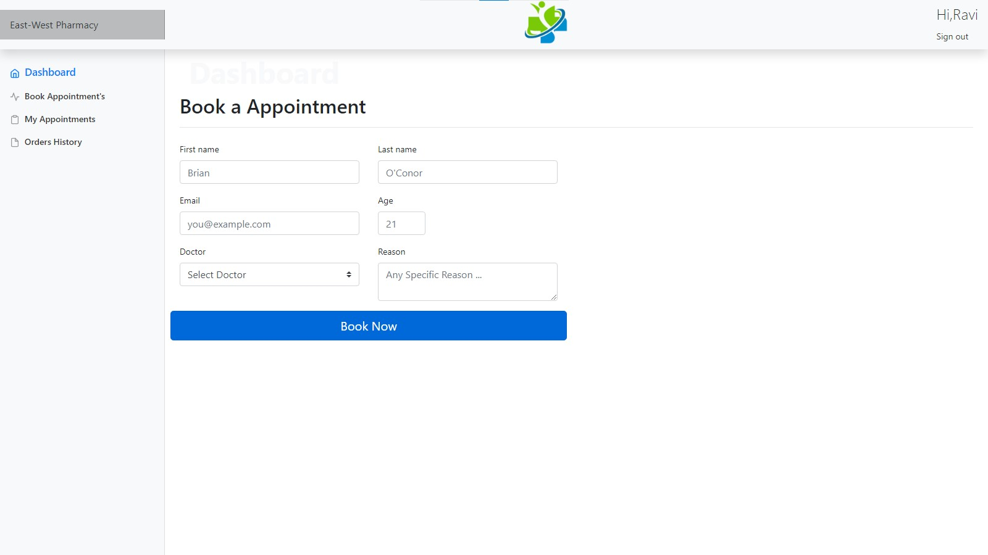

1. Here on the front you will have the section where you can book a appointment to a doctor. When filled form will look like next page picture. Here the name of the user will be automatically fetched from the database and shown above right corner as per the Customer ID entered while login.

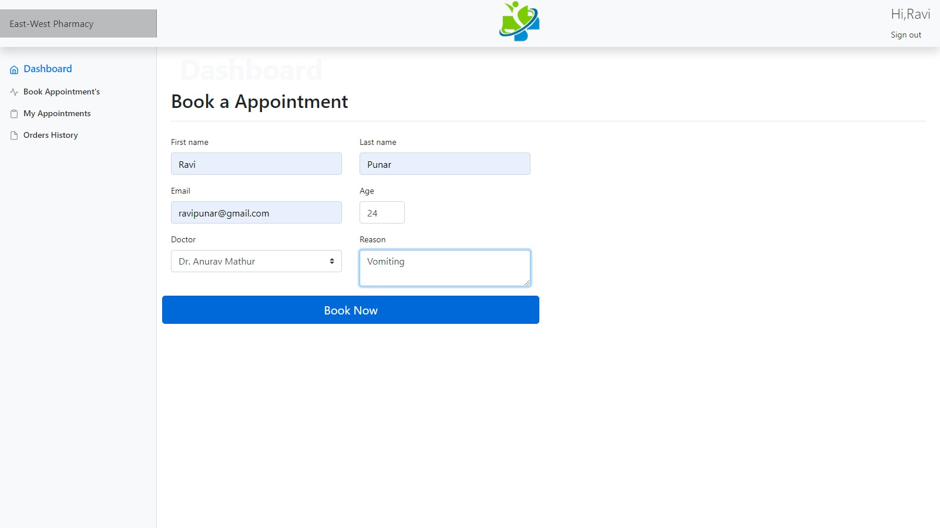

1. After filling up all the columns Click on Book now and you will be given a confirmation of the Booking as shown in the next Picture.

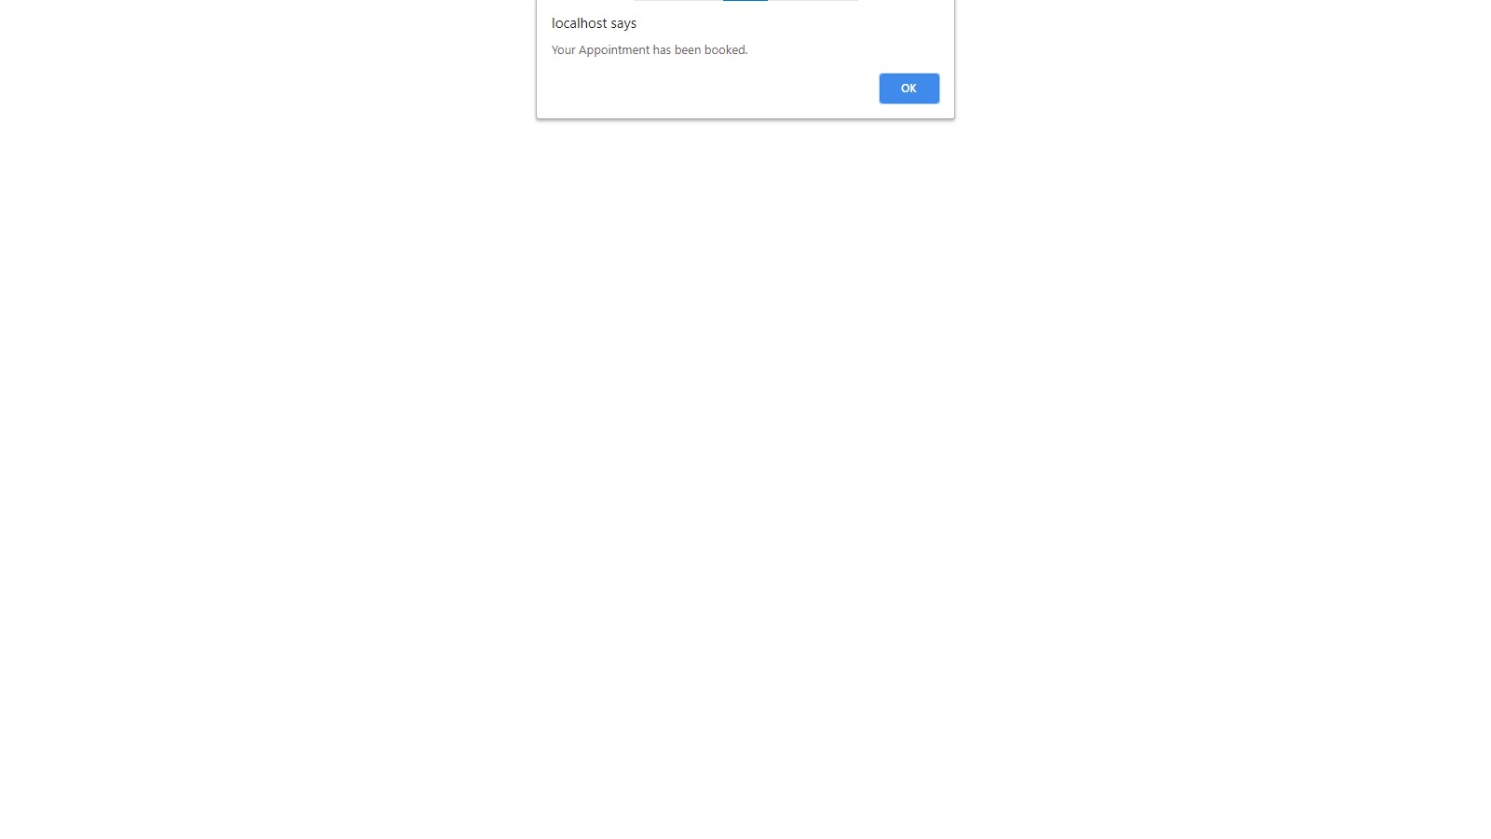

1. Appointment has been booked now. Click on OK. It will return to the dashboard.

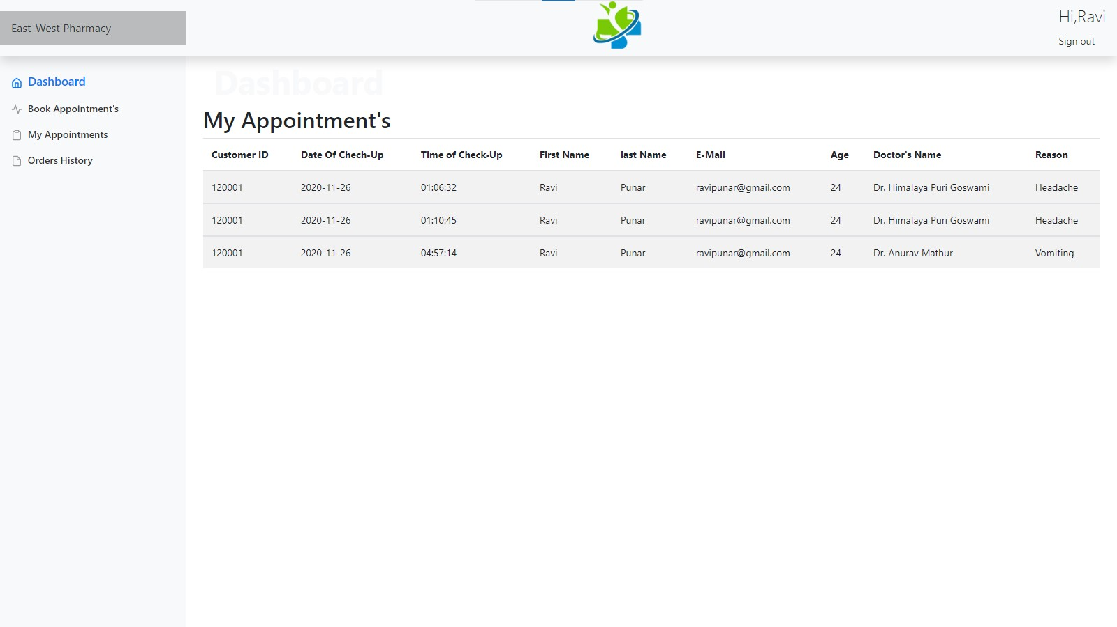

1. On the left Side Menu Bar Click on My Appointments to check the last recorded appointments including the previous history of appointments.

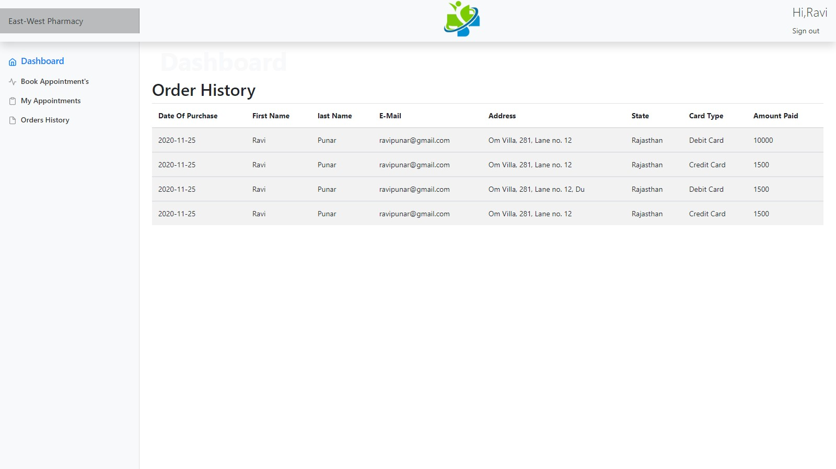

1. When you click on the left Side Menu Bar Click on Order History you can check the previous history of transaction you did on the shop or the Website to purchase the membership. Here when you click on the sign-out button on the right top corner you will be redirected to the homepage.

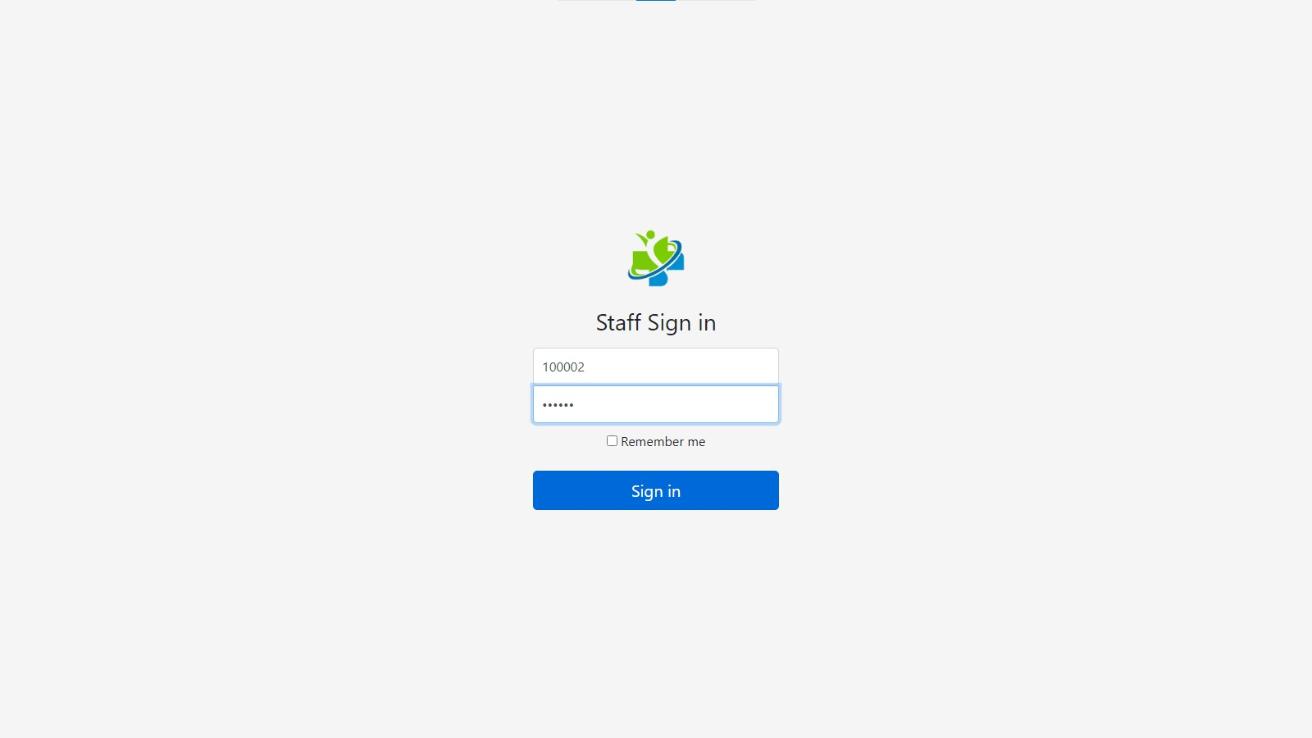

1. Staff is also checked and verified for the right credentials before signup to control unauthorized access. Here click sign-in after inserting the right ID & password and you will enter staff dashboard.

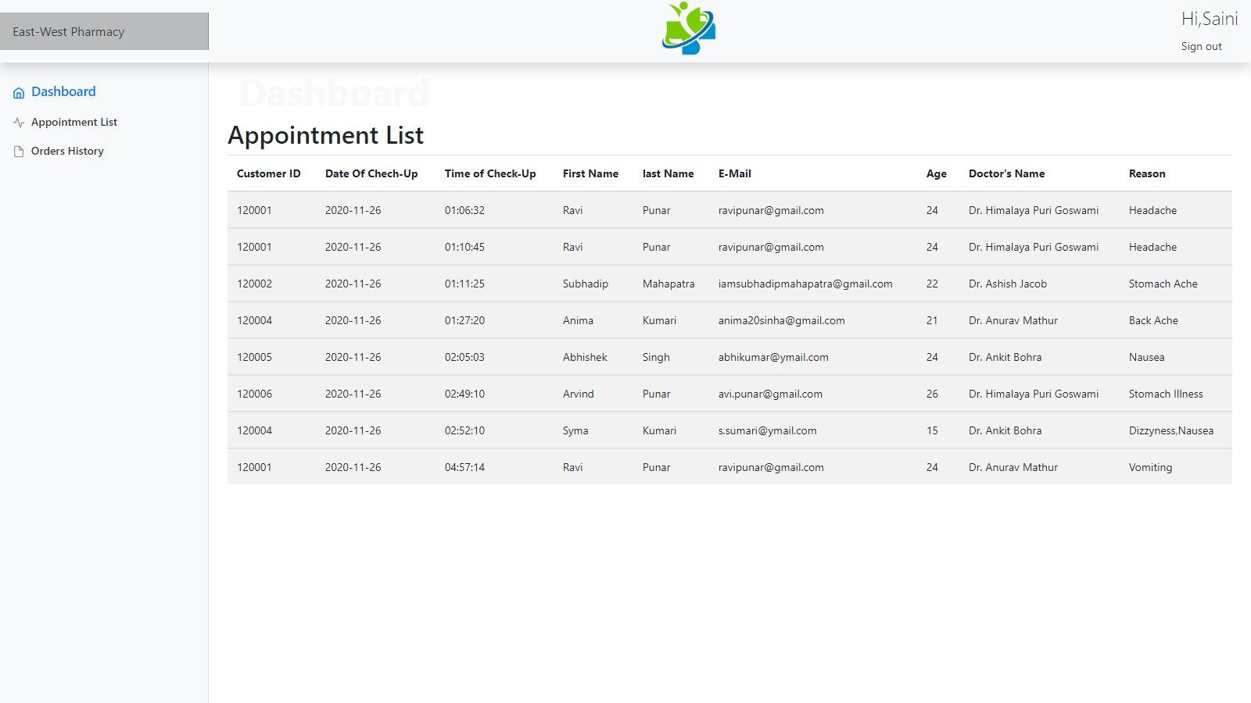

1. Here also the name is automatically taken by matching the staff id in the database. Click on the Appointment list to check all the appointments booked by all the users.

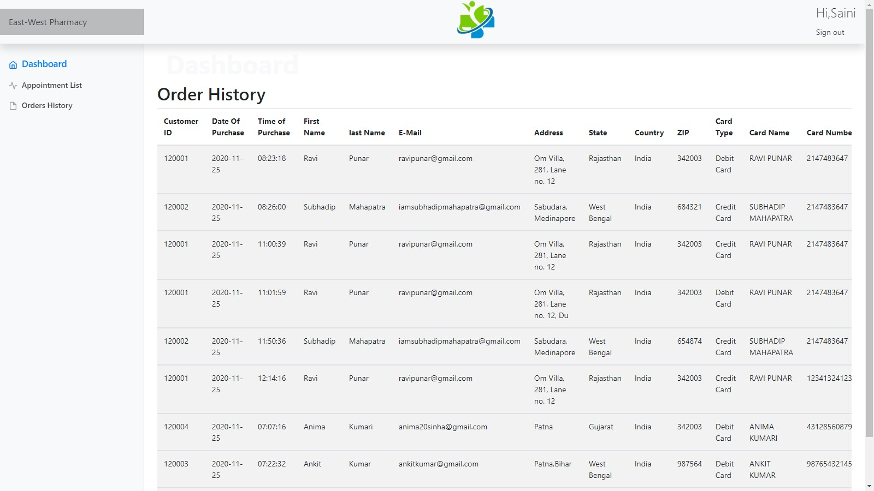

1. Click on the left side menu bar button Order history and you will fetch all the details of purchases of the users by several fields and dates with addresses and their transaction details.

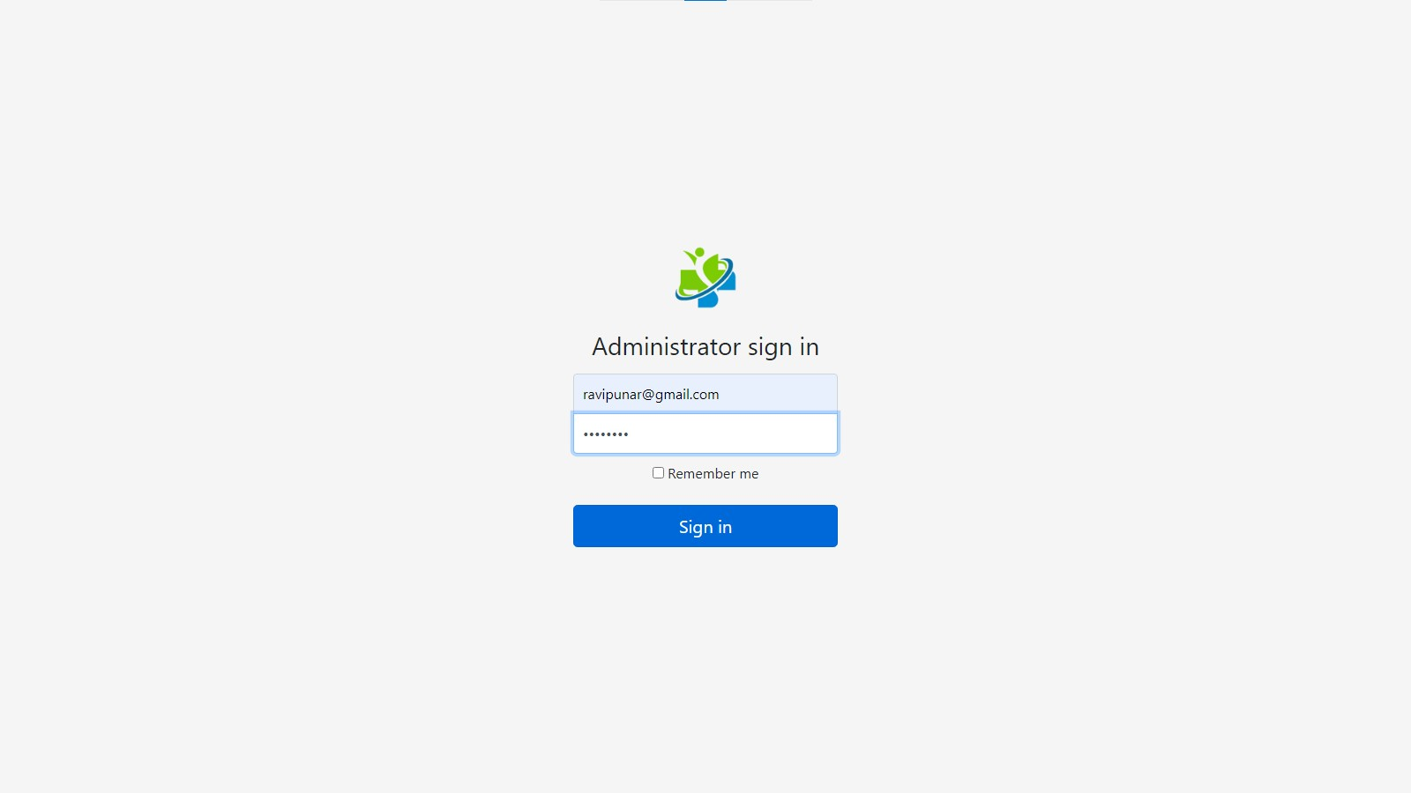

1. As usual Admin will also be authenticated to control unauthorized access with valid ID and Password. Click on Sign-in.

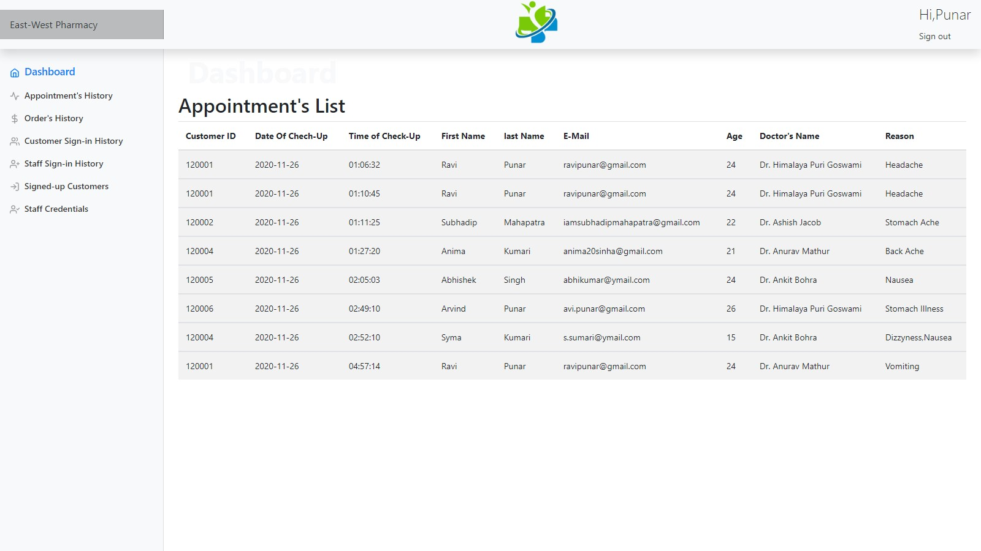

1. Admin Name will be fetched and will be provided to the dashboard page as per the Login ID and password. Where when clicked on the Appointment history it will show the following page above which has appointment details of all the users till date.

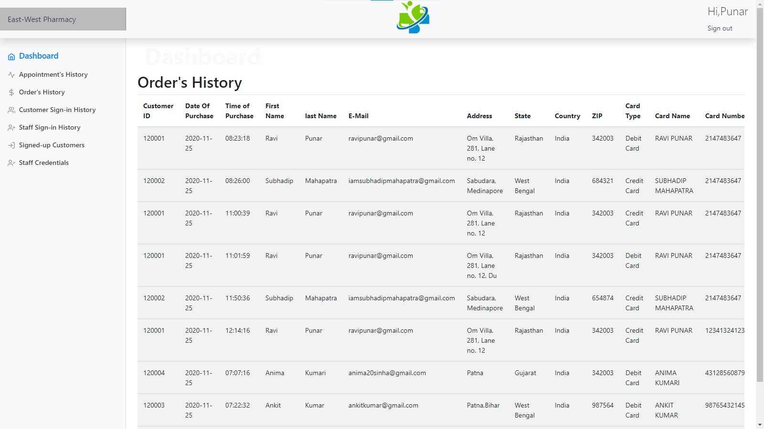

1. Click on Orders History in the left side menu bar which will return the Order history of all the customers till date.

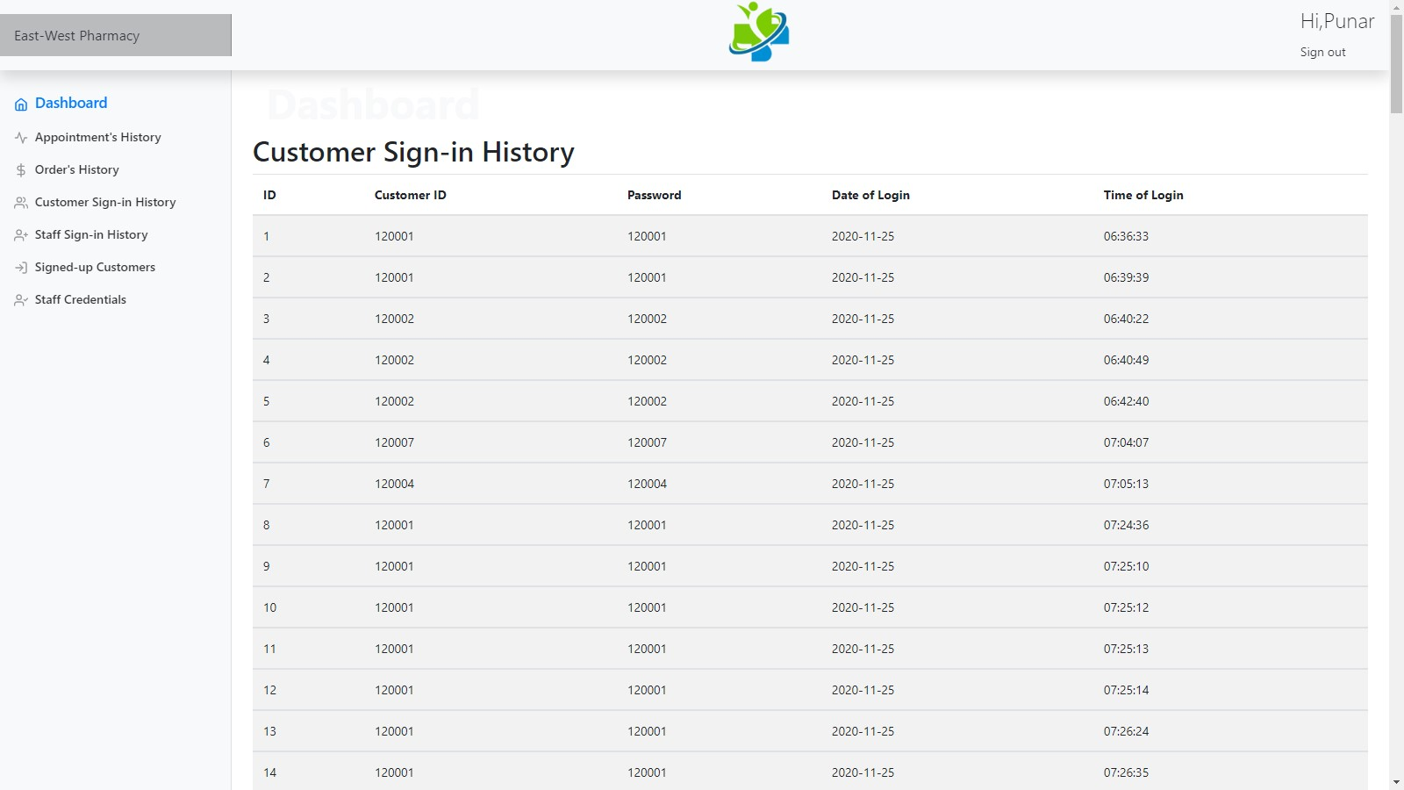

1. When clicked on Customer sign-in history on the left side menu bar will show the sign-in details of all the users with date and time(The time mentioned above is UTC time.).

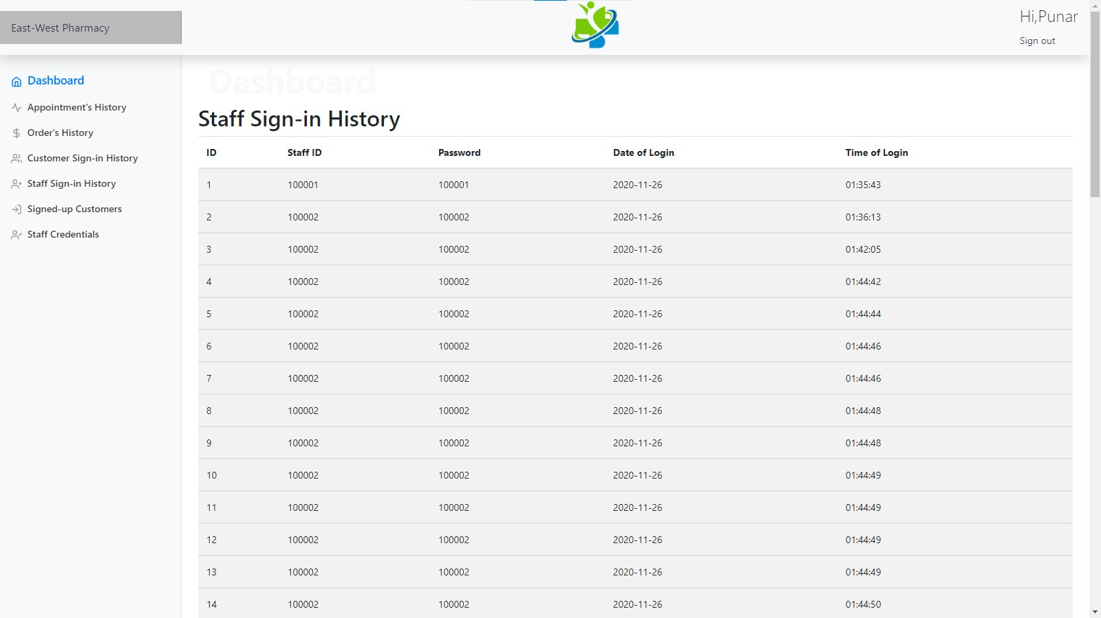

1. Here Staff sign-in History will keep record of all the details of the staff sign-in’s.

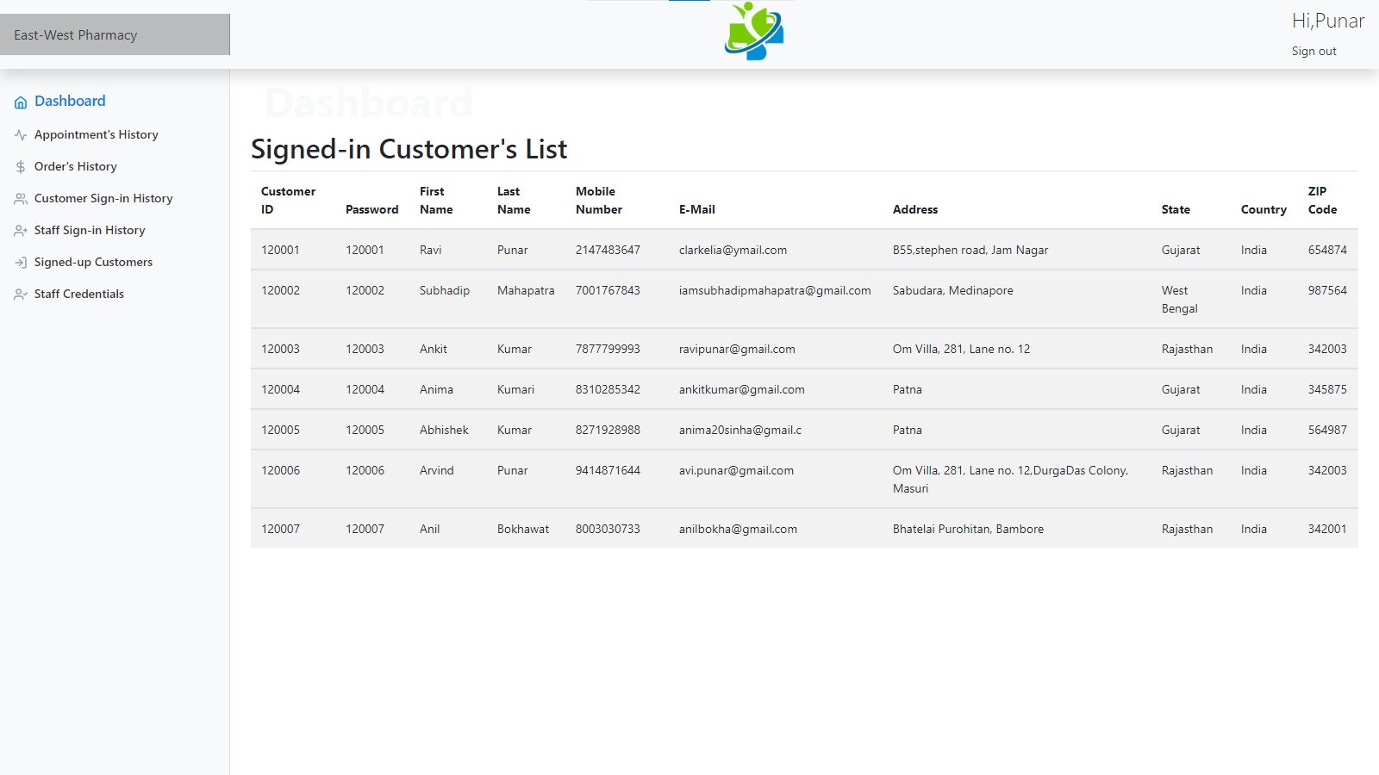

1. Click on the Signed-up Customers you will get the Signed up customer details which have recently been signed in.Here the Customer ID will be assigned to user automatically.

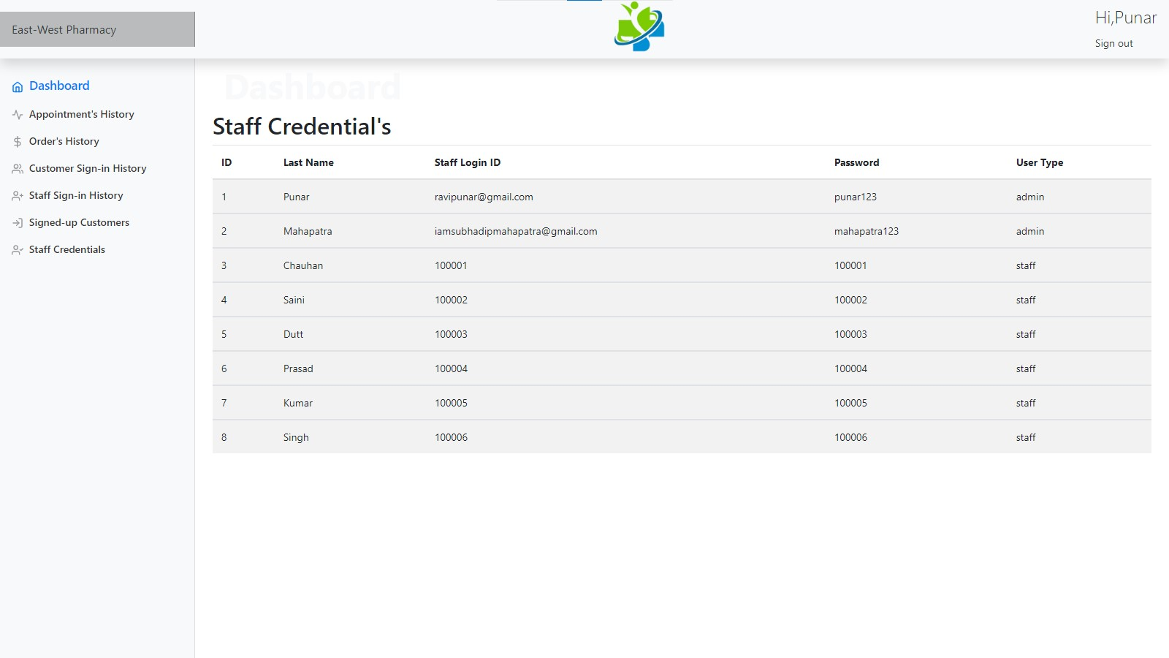

1. Click on the Staff Credentials will show all the Staff Details including their Login ID & password. After which when clicked on the Sign-out you will be redirected to Homepage.

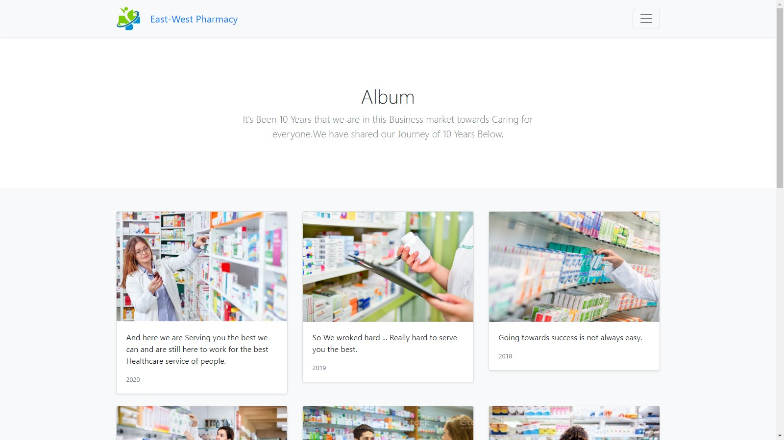

1. On the Home Click on the Navigation Menu bar option ‘Album’ to check the photos and other details about the store.

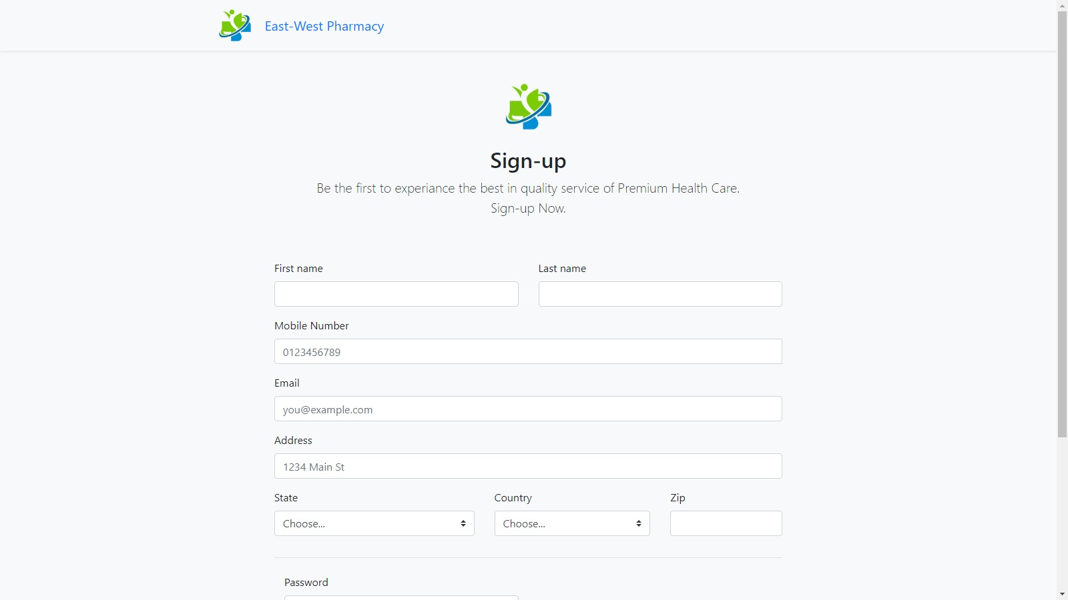

1. If anyone visiting the website does not have and login id and password, they can create a new ID by Going to the Sign-up page from the Home Page or through the Sign-in page of Customer and then click on the Home Page.Where the ID Password of the customers will be auto generated and assigned to each and saved in the sign-up database.

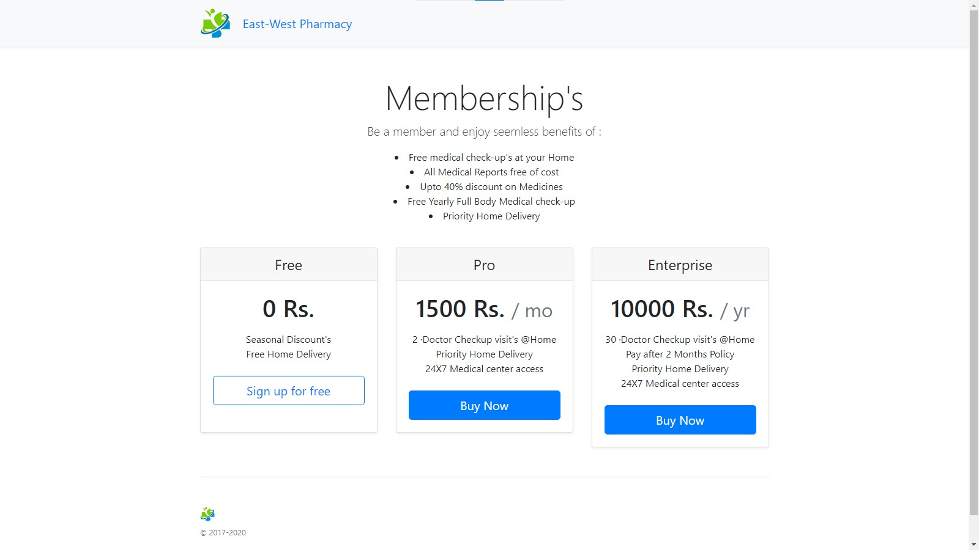

1. When you click on the Membership from the Home Page you will be redirected here where you can purchase the Membership for Month & Year.

If you want free sign-up is also done with limited benefits.

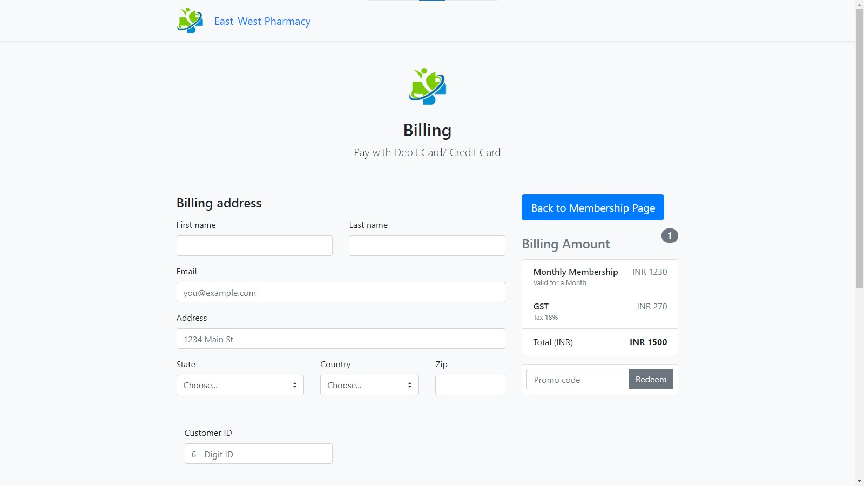

1. Here when clicked on the 1 month membership. You will be redirected here where you can purchase the plan by providing your Customer ID and avail the special benefits.

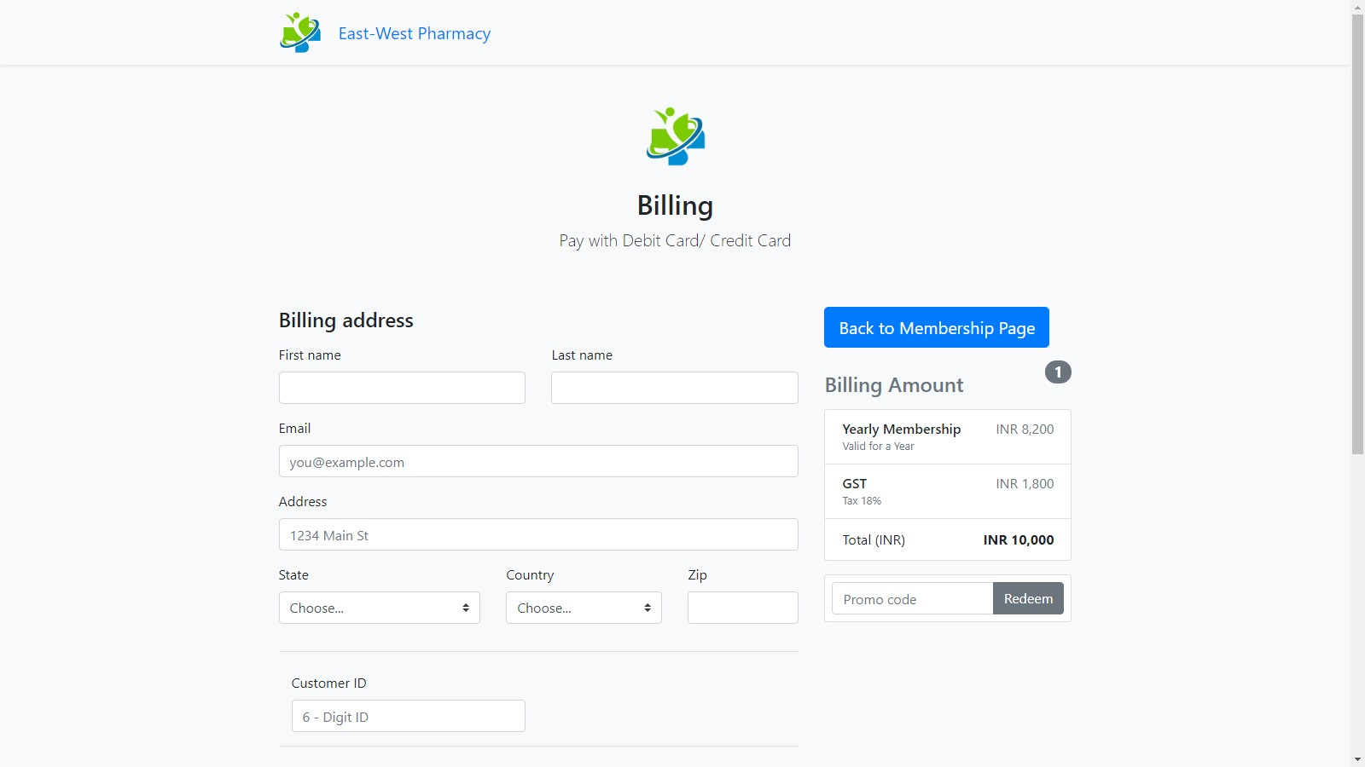

1. When you click on the 1 Year membership plan you will be redirected here and you can purchase plan by paying through Card.

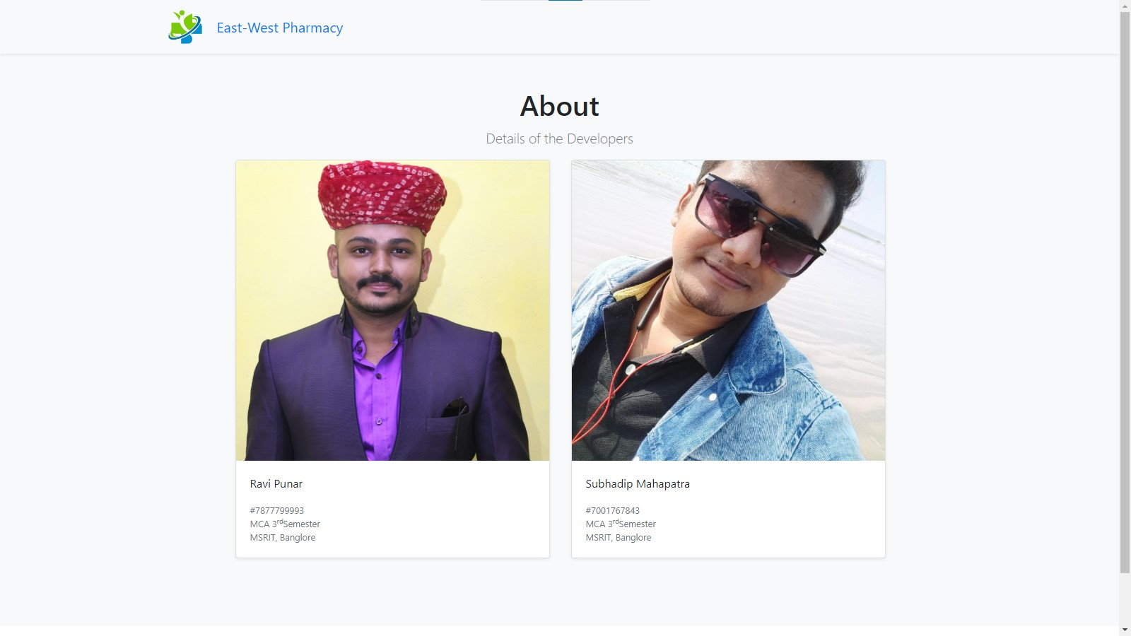

1. When you click on the About Page on the Home page you will the shown the page of the Admin Panel of the Website Who are the Developers of the PHP Website using Ajax.

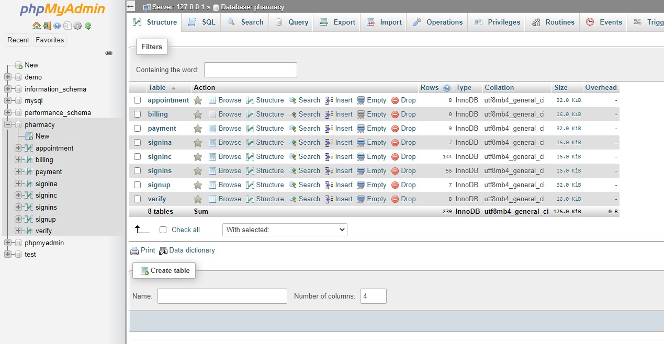

1. This is main Database Pharmacy.

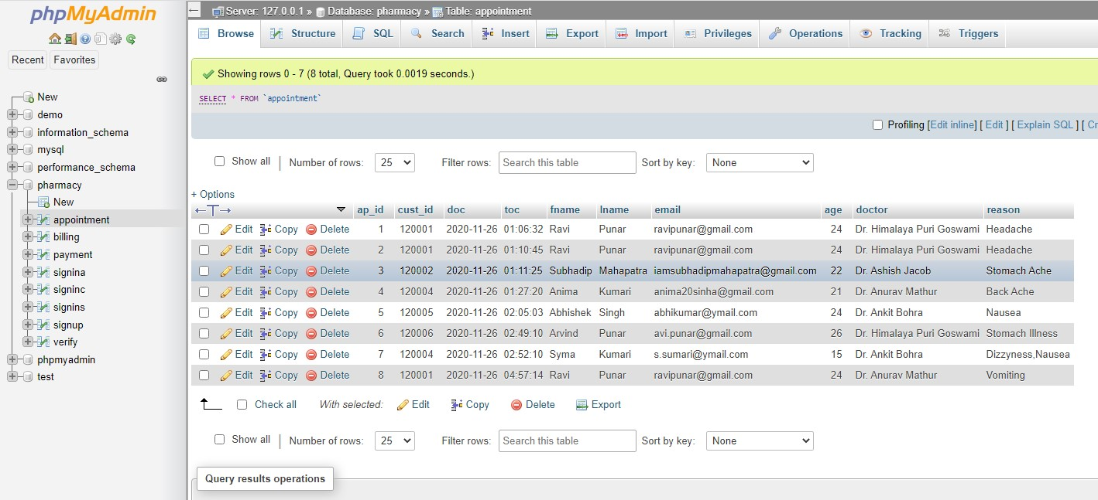

1. This the view of Appointment Table.

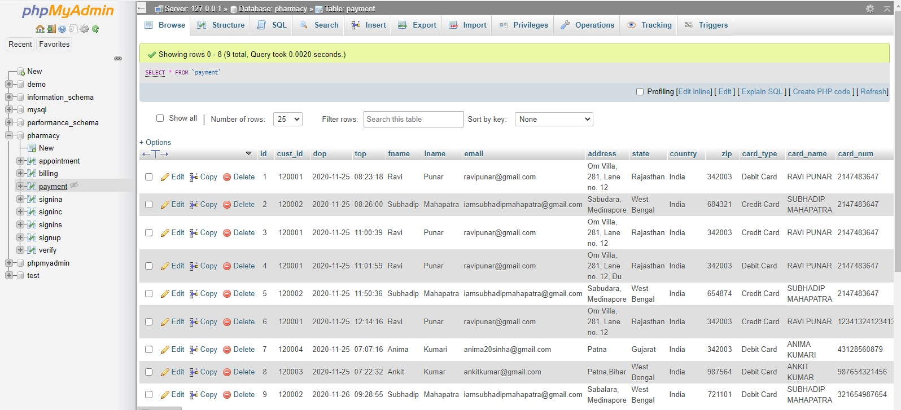

1. This the view of Payment Table.

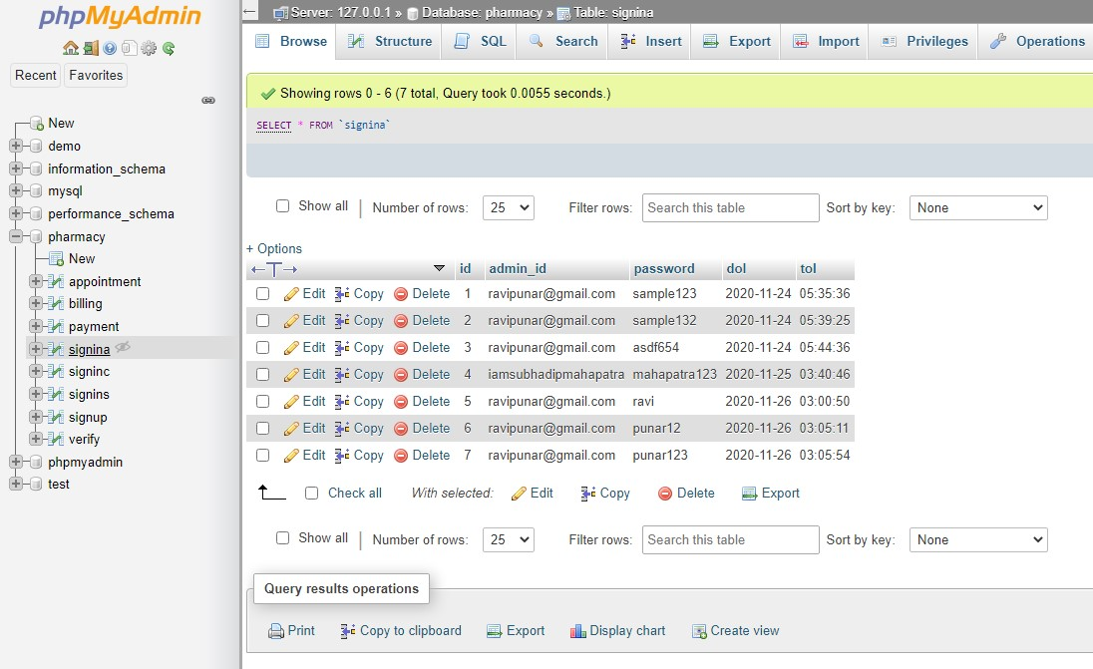

1. This is the view of Sign-in Page of Admin, keeps record of all the Admin entry to the Website Resource Database.

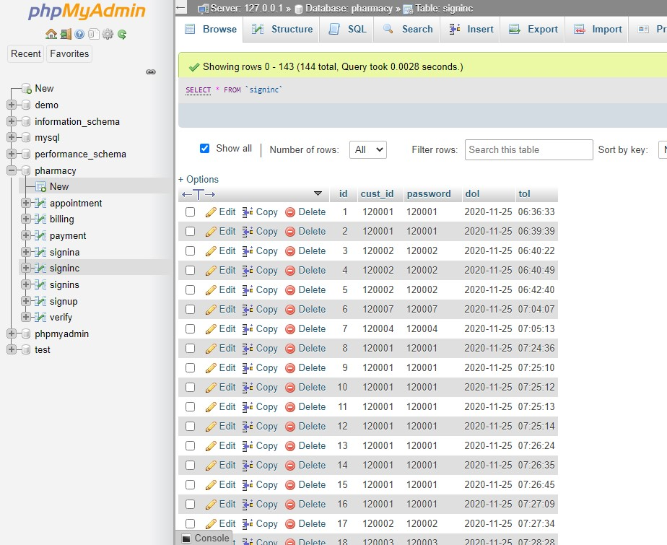

1. This is the Sign-in page of Customers, keeps record of all the logging-in customers.

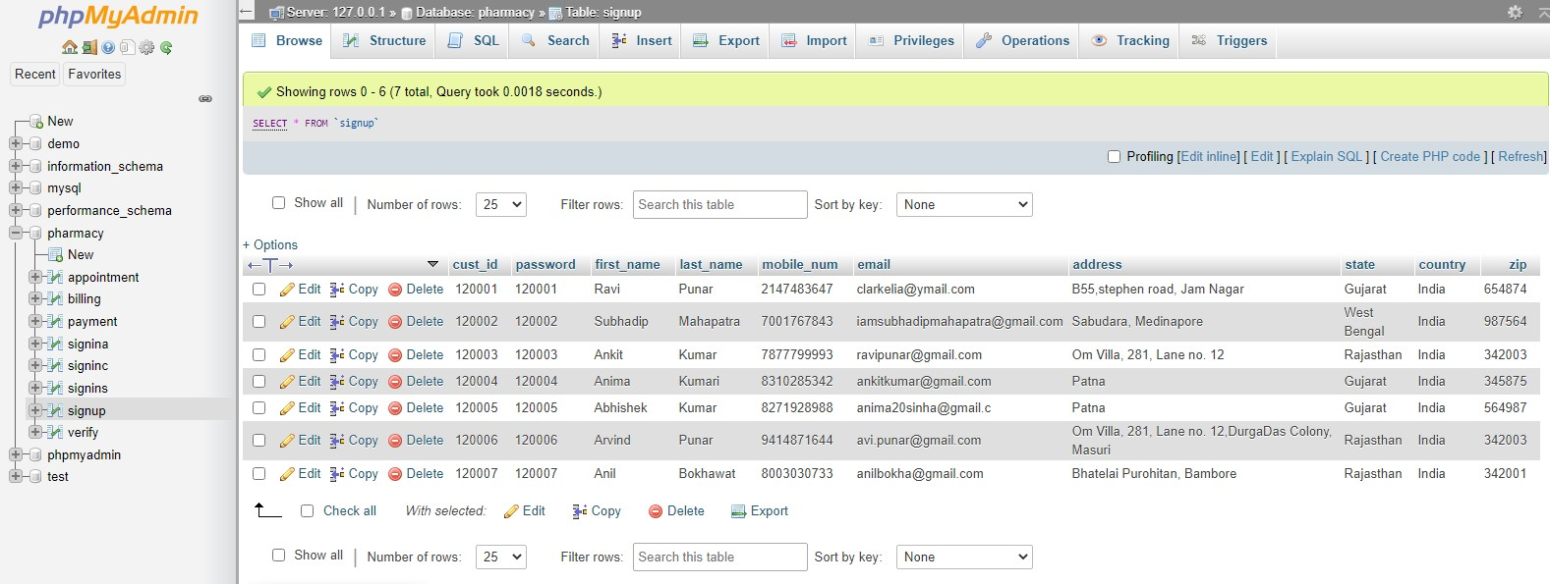

1. This is the Sign-up Page for new Customer Entry. Logging-in Customer will be matched with the credentials with the help of this Table.

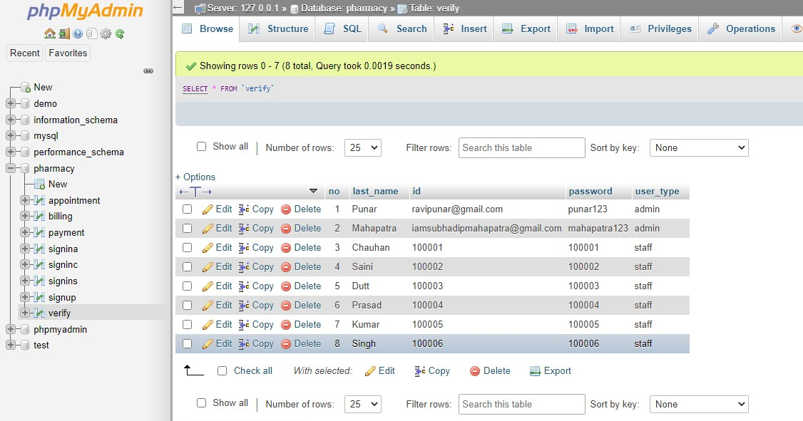

1. This is the Verify Table to match the Credential of the logging-in Staff.

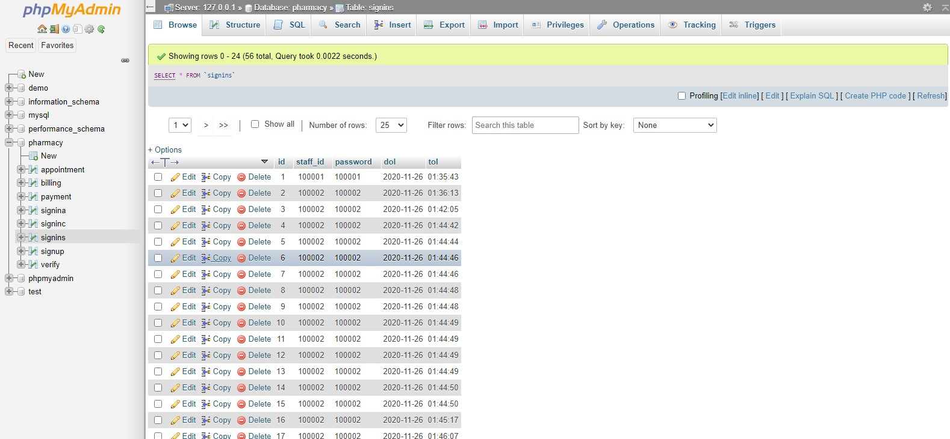

1. This is the Sign-in table of Staff, keeps record of the staff.